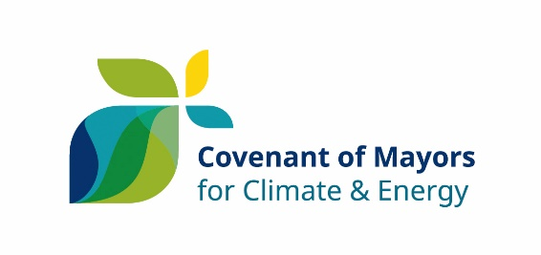
0
Joint Sustainable Energy and Climate Action Plan
Option 1

I, [Name of the Mayor (or other equivalent representative)], [Mayor (or Job title)] of [Name of the local authority] have been mandated by the [Municipal Council (or equivalent decision-making body)] on [date] to sign up to the Covenant of Mayors for Climate and Energy as part of the group named [Name of the group of Signatories], composed of [Name of the other local authorities involved in the group], in full knowledge of the commitments set out in the official Commitment Document and summarised below.
Therefore, my local authority principally commits to:
- Collectively reducing CO₂ (and possibly other greenhouse gas) emissions on our respective territories by at least 40% by 2030, namely through improved energy efficiency and greater use of renewable energy sources;
- Increasing our resilience by adapting to the impacts of climate change.
In order to translate these commitments into action, my local authority as part of the group undertakes to fulfil the following step-by-step approach:
- Carry out a Baseline Emissions Inventory and a Climate Change Risk and Vulnerability Assessment;
- Submit a Sustainable Energy and Climate Action Plan within two years following the above date of the municipal council decision;
- Report progress at least every second year following the submission of the Sustainable Energy and Climate Action Plan for evaluation, monitoring and verification purposes.
I accept that our group of local authorities shall be suspended from the initiative – subject to prior notice in writing by the Covenant of Mayors Office – in case of non-submission of the above-mentioned documents (i.e. Sustainable Energy and Climate Action Plan and Progress Reports) within the established deadlines.
[Name and complete address of the local authority]
[Name, e-mail and phone number of the contact person]

SIGNATURE

